**EECS 118**

**Knowledge Engineering and Software Engineering**

**Fall 2018**

**Term Project**

**Option II: A Geometry Problem Solver**

**Project Supplement**

**Problem Set H**

Please use Python 3.5 or above as your programming language for the solver program.

Assigned Problem:

1. Two triangles have four intersection points:

One intersection is on each one of two sides of a triangle. Two intersections are on the third side. One side of a triangle is completely inside another triangle.

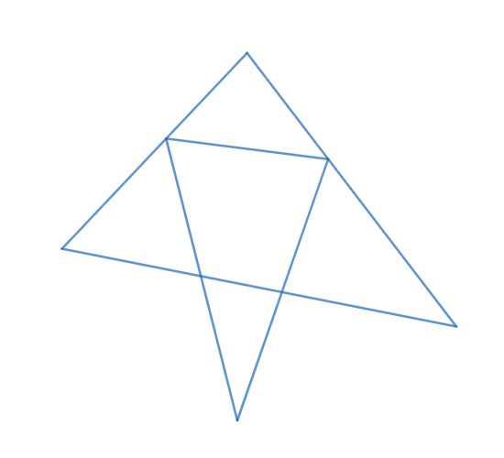

You are encouraged to draw your own diagram according to the description. The diagram above are only for your reference, you need to consider all cases as long as they meet the description. Please also consider boundary cases.

Extra Credits:

Instead of creating a solver for the above problem, design a solver that can solve any two triangle problems.

Resources:

[Learn Python in 60 Minutes from Java](https://www.youtube.com/watch?v=xLovcfIugy8)

[How to solve a triangle](https://en.wikipedia.org/wiki/Solution_of_triangles#Solving_plane_triangles): You can start here.

[Law of Sines--Ambiguous Case](http://jwilson.coe.uga.edu/EMT668/EMAT6680.2001/Mealor/EMAT%206700/law%20of%20sines/Law%20of%20Sines%20ambiguous%20case/lawofsinesambiguouscase.html): A special case.

[Single Triangle Calculator](https://www.triangle-calculator.com/): An online demo of single triangle problem solver.

[SymPy Geometry Module](https://docs.sympy.org/latest/modules/geometry/index.html): SymPy is a Python library, you may find its geometry module helpful.